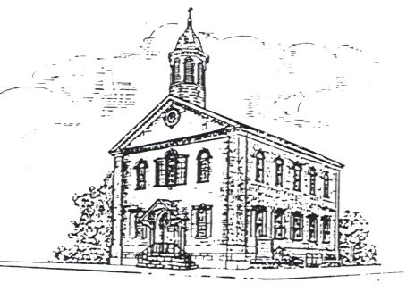

Zion’s United Church of Christ
209 Chestnut Street
Pottstown, PA 19464
(610) 323-3637

Rev. Austin Chinault, II - Pastor
Keith Clattenburg – Organist/Choir Director
Laura Clattenburg – Music Coordinator
Kimberly Kulesa - Office Administrator
Frank Moser - Custodian

Those serving this month
Sunday Worship Hours
10:15 a.m. – Sanctuary

November 5 - Worship at Trinity, 10:15 a.m.

9:00 - Intergenerational Sunday School every Sunday except November 19

Special Services & Events

All Saints Special Offering – November 5

Memorial Sunday – November 12

Consistory Meeting -
November 13, 7:00 p.m.

Congregational Meeting and Harvest Home Sunday – November 19

Bible Study - Wednesdays 12:00 to 1:00 p.m. at Trinity

Ping Pong and Pizza – Wednesdays at 5:30 p.m.

Handbell Choir Rehearsal -
Wednesdays, 6:30 p.m.

Choir Rehearsal – Wednesdays at 7:30 p.m.

Community Meal at Emmanuel Lutheran -
November 24 at 12:00 p.m.

﻿Dear Congregation:
As I write this article it is the eve of my father’s funeral. The next day I preach at the funeral of a good friend and colleague who is my age. At that same time will be the funeral of my sister’s mother-in-law, who was a prominent member of a church I served and like a grandmother to my daughter who sat with her during worship because Diane and I were busy during worship as pastor and in the choir.
Needless to say, it is an eventful and emotional weekend. But no more so than many (perhaps all) of you have also experienced. We are extremely grateful for your prayers, expressions, and spiritual support. It is an awesome thing to realize your reality of the beloved community which Christ has called forth!
Thank you. 🙏🏼
All of this leads to my emphasis upon our “Memorial Sunday” (November 12) when we honor our Book of Golden Memories. Our focus that Sunday will be from First Thessalonians where the Spirit shows St. Paul that “We will always be with the Lord.” What a wonderful promise we have from God and how appropriate to share these blessings on Memorial Sunday. It is an abiding promise of scripture that Messiah shall return in glory and that nothing will ever separate us from the eternal love of God. This is our hope…. “On Christ, the solid Rock, I stand—all other ground is sinking sand!”
Another highlight will be Harvest Home Sunday on November 19. As always, we anticipate an altar full of produce we can display to give God thanks for the beauty and bounty of the good earth. We honor God even more by sharing these goods, as we are able, with brothers and sisters in need. Our outreach throughout the year to provide food to the hungry is the true measure and fruit of our faith. “Love is something, if you give it away, you end up having more!” This proverb is literally true, as is the promise of scripture the more one gives, the more one gets: “give, and it will be given to you; good measure, pressed down, shaken together, running over, will be poured into your lap. For the measure you give will be the measure you get back.” (Spoken by Jesus, Luke 6: 38)
May God continue to bless you richly as we pursue our ministry and mission together in Pottstown and around the world. Our God is an awesome God and will pursue and protect us every step of the way as we place our trust, faith and love completely upon the Everlasting Arms.

God Bless you all, and…
Happy Thanksgiving!
Pastor Austin 🦃

The Tymes – November 2023

Altar Guild:  Diane Andres  Financial  Secretary:  Joan Miller | November 5  Joint Worship #17  at Trinity  Lectionary Readings:  Psalm 43  I Thessalonians 2: 9-13  Matthew 23: 1-12  Sermon:  “The Word of God” | November 12  Memorial Sunday (Book of Golden Memories)  Lectionary Readings:  Joshua  24: 1-3a, 14-15 (Craig Strunk)  I Thessalonians  4: 13-18 (Craig)  Matthew 25: 1-13  Sermon:  “We Shall Always be With the Lord” | November 19  Pentecost XXV  Lectionary Readings:  Psalm 123  (Joan Miller)  I Thessalonians  5: 1-11 (Joan)  Matthew 25: 14-30  Sermon:  “Lord, Have Mercy” | November 26  Reign of Christ  Lectionary Readings:  Ezekiel  34: 11-16, 20-24 (Sharon Moser)  Ephesians  1: 15-23 (Sharon)  Matthew 25: 31-46  Sermon:  “Far Above All Rule and Authority”
Financial Assistants | Diane Andres | Brenda Ross | Brian Miller | Audry Leister-Stengel
Head Usher/ Ushers | No ushers needed, service at Trinity | Jennifer Young | Susan Embody | Jim Miller

Consistory Highlights

Consistory met on Monday, October 9th.
NA’s (Narcotics Anonymous) request to hold their meeting at Zion’s once a month on a Sunday afternoon was discussed. Additional information will be reviewed at the November Consistory meeting before a decision can be made. Toys for Tots will use space at Zion’s for approximately one month to store toys for their Christmas giving. Joan Miller noted that the Church is currently experiencing challenges in meeting expenses due to fewer weekly contributions received. Pastor Austin continues with Confirmation Class and Wednesday Bible Study. He participated in the Men’s Clergy Retreat and brought attention to an appeal from Mustard Seed Malawi Mission.
Joan reviewed the proposed annual budget for Zion’s for 2024 and mentioned that wages and salary increases were based on PSEC guidelines. Consistory approved the proposed budget. The annual Congregational meeting will be in the sanctuary immediately following the church service on November 19th.
Joan and Mary Cresswell, youth and interested adults will be working on handmade cards for Zion’s homebound on November 12th. A date for the Advent workshop will be determined soon. CCLU’s After School Program continues to run smoothly.
Consistory will be seeking new members for 2024. The commitment is for one year but may be renewed, if desired.
Some reminders: Potato Filling fundraiser, November 18th with preparation on Friday, the 17th (helping hands needed);
Memorial Sunday, November 12th;
Annual Congregational Meeting with election of Consistory members,
November 19th, (in sanctuary immediately following the church service);
Cookie Walk fundraiser, December 2nd (bakers needed in advance).
Next Consistory meeting Monday, November 13th, 7:00 pm.

NEWSLETTER DEADLINE

The deadline for the December issue of the Tymes is November 20th. Please send articles to: zionsuccoffice@comcast.net

SUNDAY SCHOOL NEWS

Sunday School for youth and adults will be held at 9:00 am. The third week of the month will be Confirmation Class for the youth and there is no Sunday School that week. We are an intergenerational class and meet in the classroom next to the office in the chapel building. Lessons are usually based on the weekly lectionary with great discussions.
All are welcome!

2024 ZION’S UCC BUDGET

Enclosed in this newsletter is the 2024 budget that has been prepared by the finance Committee and approved by the Consistory on October 9th. If you have any questions regarding this information, please feel free to contact me. The budget will be presented for a vote at the Congregational Meeting on November 19, 2023.

Joan L Miller, Finance Chairperson

Cluster News

Our current needs are: Gently used (or new) and freshly laundered sheets (twin and queen sizes) and bath towels
Items for move-in kits:
sponges, cleaning cloths, paper towels, toilet plunger, dust pan and brush, rubber
cleaner gloves, mop, broom, laundry detergent, bleach surface cleaner, Lysol spray
Donations are accepted at our Outreach Center located at 57 N. Franklin Street in Pottstown Monday – Friday
Please call 610-970-5995 to schedule a delivery date and time.

Food Security

Every Monday at 4:00 p.m. balanced meals food boxes are distributed free to anyone in need. The location is Bethel Community Church of Pottstown, 575 N. Keim St. Pottstown. This ministry is supported through the Pottstown Ministerium. Please pass the word to anyone with a need for food.

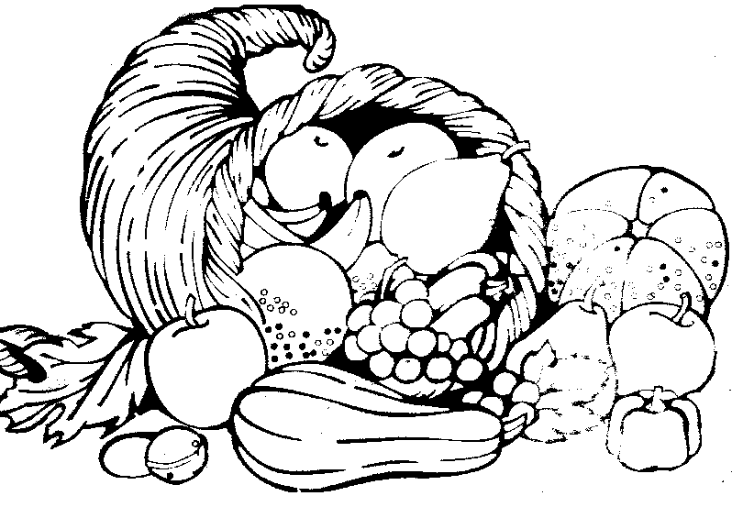
The altar guild is asking for donations of fresh fruits and vegetables for the altar for Thanksgiving. If you would like to donate something to add to the harvest bounty, please drop it off in the lobby of the Sunday School building by November 18th. These fruits and vegetables will be donated to the Salvation Army after the worship service on November 19th to be shared with families in need.
Some suggested items are:
apples, grapes, pears, cabbage, potatoes, turnips, eggplant, carrots, Brussel sprouts, sweet potatoes, pumpkins, nuts, beets, zucchini, squash, celery, onions, cucumbers, broccoli, and cauliflower.
If you have any questions, please contact Julie at 610-689-5169. We look forward to worship on this special Sunday when we give thanks to God, the source of all bounty.

PSEC All Saints Offering

All Saints Sunday is the first Sunday in November. We celebrate long ago saints and those we know as saints today; people who inspired us by grit and determination to "keep on trying." Many of these people are pastors whose lives shaped and influenced our own. Some of the PSEC pastors who retired years ago are now in need of special assistance. Because their retirement income is low, the churches of the Pennsylvania Southeast Conference supplement the cost of their health benefits.
We remember these saints as we receive the PSEC special All Saints Offering. Your generosity will bring peace of mind and improved health to those who have served the church so faithfully in the past. The entirety of the offering is used to supplement the needs of 5 of the retired pastors, spouses, and widows in the Pennsylvania Southeast Conference who need assistance with health and dental insurance.
Be a saint to those who have been saints and support this vital ministry on November 5. Envelopes are enclosed.

HAPPY BIRTHDAY!

November 1 - Elaine Richards
2 - Audry Leister-Stengel
Elizabeth Miller
3 - Robert Gauger
7 - Elisa Bartolini
9 - Sandy Strunk
12 - Timothy Camacho
13 –Everly Rhoads
Linda Miller
16 - Dan Oister
22 - Spencer Mitchell
23 - Rachael Jones
24 - Abby Albitz
25 - Shari Albitz
Richard Adinolfi
26 - Nancy Bortz

Happy Anniversary !

Dusty and Julie Rhoads
45 years on November 4
James and Patricia Whisler
52 years on November 6
Kyle and Amanda Moser
14 years on November 14
Robert and Mary Cresswell
27 years on November 24
Daniel and Lois Oister
46 years on November 25
Guy and Andrea Porter
14 years on November 28

Christmas Cookie Walk and More! December 2, 2023

We will be having a cookie sale and are looking for volunteer bakers. Please contact Sharon Moser if you would like to bake. We then will be selling our cookies by the pound on Dec 2, 2023. There will also be specialty items for sale, so if you are not a baker but make chocolate covered pretzels, fudge or some other wonderful tasting goodie, please let us know.
We also would welcome any vendor who would have handmade items for sale, they may set up also.
Please contact Diane Andres or Sharon Moser if you have any questions or would like to volunteer to help. Thanks!

Beacon of Hope Homeless
Shelter 2023-2024 Donations

Pottstown Beacon of Hope, in collaboration with borough leadership, St. Paul’s UCC, St. James Lutheran, Bethel Community Church, Congregation Hesed Shel Emet, First Baptist Church, Christ’s Episcopal Church, and First Presbyterian Church, will be opening an overnight warming center for the winter season. From November 1, 2023, to May 1, 2024, the center will operate daily from 7 pm to 7 am, providing a warm refuge for individuals experiencing homelessness, rotating between houses of faith and churches each month.
Once open, we will need volunteers to assist with meals, cleaning, driving guests, and organizing of donations. If you interested in supporting our efforts this winter season, please call 484-625-1818 or visit the website: www.pottstownbeaconofhope.org for more information and to sign up to help.
We are grateful to the 100+ volunteers that supported our guests throughout the 22-23 winter month at St. Paul’s UCC in Pottstown.
To make a monetary donation you can send your gifts to Zion’s (marked homeless donation), made payable to Zion’s UCC. We will send the donations received to Beacon of Hope to help with this important ministry to our neighbors.

Redner’s Receipts!

Please place your Redner’s Save-a-Tape receipts in the box in the lobby of the Sunday School building. We need the entire register tape in order to get credit. Also’ it has to have the words Save-a-Tape on it. Redner’s will donate 1% of sales to our church.
Placing your grocery receipts in the box is an easy way to help Zion’s!!

Redner’s and Giant Market
Gift Cards Sales

Members and friends may purchase a Giant and/or Redner’s Gift card to use for groceries or gas. Denominations of cards come in $25, $50, or $100. There is no charge to you but our church receives 5% of the grocery card purchase price.
Gift cards to Redner’s or Giant are available Sundays in the Christian Education building or during the week through the church office.
The Handbell Choir

In the early 1990’s, Leonard and Elsie Huff, longtime members, inquired if there was interest here at Zion’s in establishing a bell choir. If so, they were willing to purchase and donate a set of handbells. Zion’s answer was yes. A two-octave set of Schulmerich Bells was donated to Zion’s by the Huff’s in 1994.
The company selected, Schulmerich Bells, is located in Hatfield, Pennsylvania. Established in 1935, they are the oldest existing manufacture of handbells in the United States. Their hand-crafted bells are made of bronze (80% copper/20% tin). It takes approximately two weeks to produce a single bell. Costs range from $1800.00 to as high as $5000.00 or more for a two-octave set which consists of 25 bells.
Eight people are required to play two octaves. Our first bell choir director was Betty Nichols. Bells did not have a director for some time until Rev. Mary Etta Mest, a new organist, reorganized the choir. Our current organist, Keith Clattenburg has continued the call.
Thank you, director Keith, and our faithful ringers – Bambi, Jim, Heather, Louise, Laurs, Diane, Joan, and Brian, who ring beautiful music to the “Glory of God” and Zion’s congregation every month.

Thanksgiving

When the golden leaves of autumn
Lie rejected on the ground
And the heavy hand of winter
Closes in on all around;

When the flowers of the summer
Have all vanished with the frost
And the harvest of the season
Has been gathered against loss;

As the geese wing slowly southward
Where the warmer regions lie
And the year is swiftly ebbing
With the moments as they fly;

Then the autumn brings Thanksgiving
To our God for all His love.
For His care and many blessings,
We shall lift our eyes above.

As the hymns of praise and thank you
Fall upon each listening ear,
Let us offer true thanksgiving
To our God all through the year!

◄ | November 2023
Sun | Mon | Tue | Wed | Thu | Fri | Sat
 |  |  | 1  Wednesday Crew  Quilters  Bible Study, 12:00 to 1:00 pm at Trinity  Ping Pong and Pizza, 5:30 pm  Handbell Rehearsal,  6:30 pm  Choir Rehearsal, 7:00 pm | 2 | 3 | 4
5 Daylight Saving Time Ends  Worship Service at Trinity  All Saints Special Offering | 6 | 7 Election Day | 8  Wednesday Crew  Quilters  Bible Study, 12:00 to 1:00 pm at Trinity  Ping Pong and Pizza, 5:30 pm  Handbell Rehearsal,  6:30 pm  Choir Rehearsal, 7:00 pm | 9 | 10 | 11 Veterans Day
12  Memorial Sunday | 13  Consistory Meeting, 7:00 pm | 14 | 15  Wednesday Crew  Quilters  Bible Study, 12:00 to 1:00 pm at Trinity  CCLU Meeting,  5:00 pm  Ping Pong and Pizza, 5:30 pm  Handbell Rehearsal,  6:30 pm  Choir Rehearsal, 7:00 pm | 16 | 17 | 18  Potato Filling pickup
19  Harvest Home/Thanksgiving Sunday  Congregational Meeting | 20  December Newsletter deadline | 21 | 22  Wednesday Crew  Quilters  Bible Study, 12:00 to 1:00 pm at Trinity  Ping Pong and Pizza, 5:30 pm  Handbell Rehearsal,  6:30 pm  Choir Rehearsal, 7:00 pm | 23 Thanksgiving Day | 24  Community Meal at Emmanuel, 12:00 pm | 25
26 | 27 | 28 | 29  Wednesday Crew  Quilters  Bible Study, 12:00 to 1:00 pm at Trinity  Ping Pong and Pizza, 5:30 pm  Handbell Rehearsal,  6:30 pm  Choir Rehearsal, 7:00 pm | 30

Potato Filling Sale
We are going to have a potato filling sale this year in place of our beloved ham supper. We will be taking orders for pans of potato filling to be picked up between 11:00 a.m. and 2:00 p.m. on Saturday, November 18th. (Just in time for Thanksgiving!) We will need help on Friday, November 17th to peel potatoes and chop veggies. We’ll start peeling around 8:00 a.m. and continue until there are no more potatoes left to peel. 😊

The filling will be sold in 13 x 9 inch pans at a price of $22.00 each and in smaller 12 x 6 inch pan for $15.00 each. If you would like to have a pan (or pans) of filling, please fill out the order form below and send it with your payment to the church office. Don’t forget to order for Christmas, too. It freezes well and will last for a couple months.

There will also be containers of deviled ham salad available for purchase at a cost of $6/pound.

The deadline for ordering is Sunday, November 12th.

*Pick up will be between 11:00 a.m. and 2:00 p.m. in the dining room Saturday,
November 18th. *

If you have any questions, please call either Julie or Elaine.

Thanks for your support of this fundraiser.
Elaine and Julie

Please return the form below with your payment by November 12th

Potato Filling Order Form

Name: Phone Number: _____

Pans ordered: @ $22.00 each Cost: ____________
Pans ordered: _____________@ $15.00 each Cost: ____________
Ham Salad: _____________@ $6.00 /pound Cost: ____________
Total Cost: _____

Zion’s United Church of Christ
209 Chestnut Street
Pottstown, PA 19464
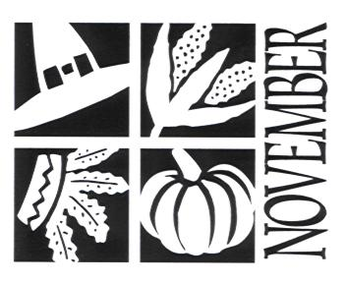
Newsletter

There is no Holy One like the Lord

1 Samuel 2:2

